Concerns for choosing a model
- Accuracy
- Interpretability
- Confusion matrix
- Ethical concern

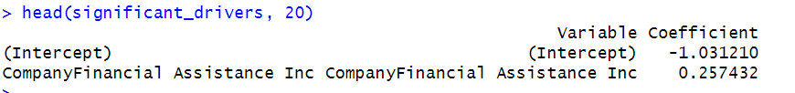
Lasso performance
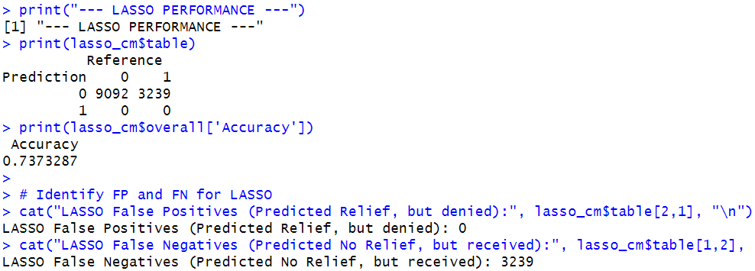

TREE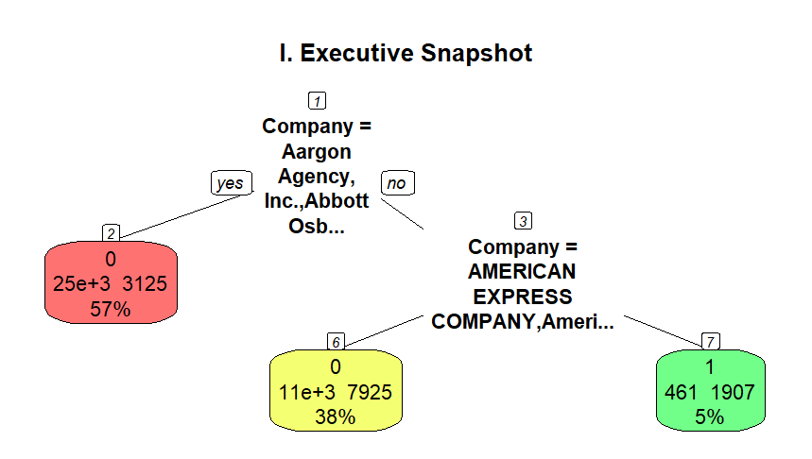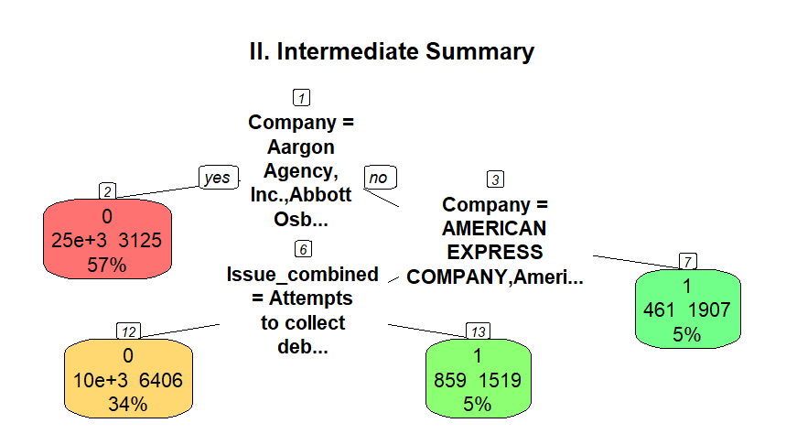

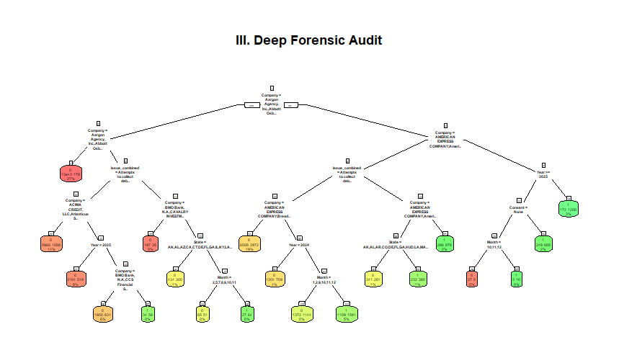
Tree performance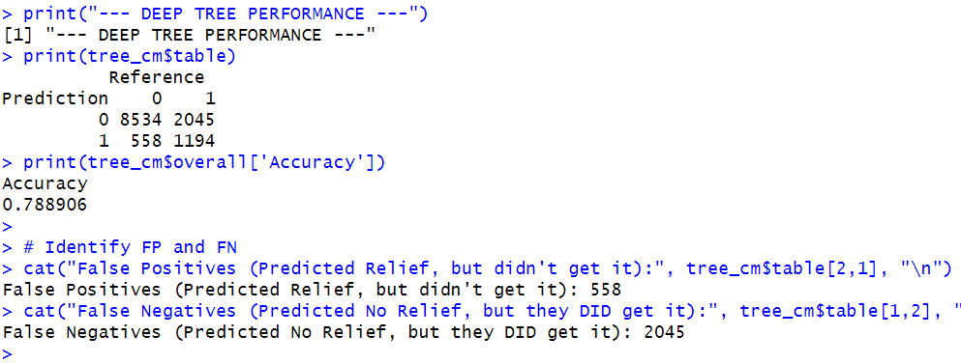
Explanation of the detailed tree -
The tree begins with a total sample of 49,325 observations, where the baseline probability of relief is 26.3%.

1. The Root Split (Level 1)
The model determines that the single most important predictor is the Company. It splits the entire dataset into two primary groups:
- Node 2 (The "High-Volume/Low-Relief" Group):
  - Starts with: Aargon Agency, Inc.
  - Relief Probability: 11.2% (drops significantly from the 26% baseline).
  - Meaning: If a complaint is filed against a company in this massive list, the consumer is statistically unlikely to receive relief.
- Node 3 (The "Power List" / High-Relief Group):
  - Starts with: Alliance One, Inc.
  - Relief Probability: 46.1% (nearly doubles the baseline).
  - Meaning: This group includes major players (AMEX, Citibank, Wells Fargo). Being in this branch is the first requirement for a high-probability relief prediction.

2. The Second Split (Level 2)
The tree then branches out differently for each group:
From Node 2 (The Low-Relief Group):
- Split: It filters for a "Core" list of companies (Node 4) vs. a "Volatility" list (Node 5).
- Node 4 Outcome: Starts with Aargon Agency. Relief probability crashes to 1.3%. This is a dead end for relief.
- Node 5 Outcome: Starts with ACIMA CREDIT. Relief probability rises slightly to 19.9%.
From Node 3 (The Power List):
- Split: It separates "Specialized Collectors" (Node 7) from "General Financial Institutions" (Node 6).
- Node 7 (The "Jackpot"): Includes Alliance One, Inc. and Transunion.
  - Relief Probability: 80.5%. This is the most successful path in the entire tree.
- Node 6: Includes AMERICAN EXPRESS. Relief probability is 41.7%.

3. Deeper Forensic Insights
As the tree moves into Level 3 and 4, it introduces Issue_combined, Year, and State:
- The Identity Theft/Bankruptcy Path (Node 10): For the Node 5 companies, if the issue is "Debt was result of identity theft" or "discharged in bankruptcy," the probability of relief is 18.4%.
- The Recent Year Surge (Node 43): Within certain company groups, complaints filed in the latter half of 2024 (Year >= 2024.5) see a jump in relief probability to 30.9%, compared to older complaints.
- The Geographical Factor (Node 53): For certain Power List companies, consumers in specific states (including CA, NY, TX, NJ, IL) have a much higher relief rate of 62.1% when reporting communication tactics (harassment/repeated calls), whereas other states (Node 52) only see 43.3%

TREE Detailed
> print(tree_deep)
n= 49325

node), split, n, loss, yval, (yprob)
* denotes terminal node

1) root 49325 12957 0 (0.73731374 0.26268626)
2) Company=Aargon Agency, Inc.,Abbott Osborn Jacobs PLC,Ability Recovery Services, LLC,Abrahamsen Gindin LLC,Absolute Resolutions Corp.,ACIMA CREDIT, LLC,Admin Recovery, LLC,Affirm Holdings, Inc,AFNI INC.,Aldous & Associates, PLLC,Aldridge PIte Haan, LLP,Alliant Capital Management LLC,ALLY FINANCIAL INC.,Alorica Inc.,American Coradius International LLC,American Recovery Service Incorporated,Amsher Collection Services, Inc.,Andreu, Palma & Andreu, PL,Apelles, LLC,Arcon Credit Solutions LLC,Army and Air Force Exchange Service,ARS National Services, Inc.,Asset Recovery Solutions, LLC,Associated Credit Services, Inc.,Atlantic Recovery Solutions LLC,Atlanticus Services Corporation,AUSSRQ Holdings, LLC,Avant Holding Company, Inc.,BANK OF AMERICA, NATIONAL ASSOCIATION,BARCLAYS BANK DELAWARE,Blitt and Gaines, P.C.,Block, Inc.,BMO Bank, N.A.,Bounce AI, Inc.,Bridgecrest Acceptance Corporation,Brock & Scott, PLLC,BTH Management,Buckles & Buckles, P.L.C.,Bull City Financial Solutions, Inc,CAINE & WEINER COMPANY, INC.,Capital Accounts, LLC,Capital Management Services, LP,CAPITAL ONE FINANCIAL CORPORATION,CAVALRY INVESTMENTS, LLC,Cawley & Bergmann, LLP,CCS Financial Services, Inc.,Cedars Business Services, LLC,Central Portfolio Control Inc.,Chime Financial Inc,CITIZENS FINANCIAL GROUP, INC.,CL Holdings LLC,CLGF Holdco 1, LLC,Client Services, Inc.,Collection Bureau of the Hudson Valley, Inc.,Collection Management Holdings, LLC,Colony Brands, Inc.,Conn's, Inc.,Consumer Adjustment Company Incorporated,Continental Finance Company, LLC,Continental Services Group, Inc. d/b/a ConServe,Convergent Resources, Inc.,Cooling & Winter LLC,Couch Lambert LLC,CREDIT ACCEPTANCE CORPORATION,Credit Card Receivables Fund Incorporated,Credit Control, LLC,Credit Corp Solutions Inc.,Crown Asset Management, LLC, Duluth, GA Branch,CURO Intermediate Holdings,D&A Services, LLC,Data and Contact Management Solutions, LLC,Data Search NY, Inc.,Debt Recovery Solutions, LLC,Diverse Funding Associates LLC,Diversified Adjustment Service, Inc.,Dynamic Recovery Solutions, LLC,Eastern Account Systems of Connecticut, Inc.,Eaton Group Attorneys LLC,ENOVA INTERNATIONAL, INC.,EOS Holdings, Inc.,ERC,Everest Receivable Services Inc.,Experian Information Solutions Inc.,F.H. Cann & Associates, Inc.,FAIR COLLECTIONS & OUTSOURCING, INC.,FIFTH THIRD FINANCIAL CORPORATION,Financial Assistance Inc,Financial Business and Consumer Solutions.,Financial Recovery Services, Inc.,First Credit Services Inc.,FIRST NATIONAL BANK OF OMAHA,First National Collection Bureau, Inc.,FIRST PORTFOLIO SERVICING INC,Firstsource Business Process Services, LLC,FISERV FINXACT CORE,FMA Alliance, Ltd.,Forster & Garbus LLP,FREEDOM FINANCIAL NETWORK,Frontline Asset Strategies, LLC,Future Judgement Solutions,Galaxy Capital Acquisitions, LLC,Gatestone & Co. International Inc.,General Motors Financial Company, Inc.,Glass Mountain Capital, LLC,Glasser and Glasser, PLC,Gordon, Aylworth & Tami, P.C.,Grain Technology, Inc.,Guglielmo and Associates,Gurstel Law Firm, P.C.,Halsted Financial Services, LLC.,Hayt Hayt & Landau, P.L. (FL),HCFS Healthcare Financial Services of TeamHealth,HSBC NORTH AMERICA HOLDINGS INC.,Hunt & Henriques,HUNTINGTON NATIONAL BANK, THE,HW Holding, Inc,I.C. System, Inc.,InDebted Corporation,IQOR US INC,Jacob Law Group, PLLC,January Technologies, Inc,Javitch, Block & Rathbone LLC,John C. Heath, Attorney at Law, PLLC,Johnson Mark LLC,JPMORGAN CHASE & CO.,JTM Capital Management, LLC,Kikoff Inc.,Kirschenbaum & Phillips P.C,Klarna AB,Klima, Peters & Daly, P.A.,Kohn Law Firm S.C.,Kramer & Frank, P.C.,Law Office of Michael J. Scott, PC,Law Offices of Hayt, Hayt & Landau, LLC,LendingPoint Holdings LLC,Lendmark Financial Services,Levy & Associates, LLC,LJ Ross Associates,Lloyd & McDaniel, PLC,Lockhart, Morris & Montgomery Inc.,Love, Beal & Nixon, P.C.,LTD Financial Services, L.P.,Lyons, Doughty & Veldhuis, PC,Malen & Associates, p.c.,Mandarich Law Group, LLP,MARINER FINANCE, LLC,Marlette Funding, LLC,McCarthy, Burgess & Wolff, Inc.,MERCANTILE ADJUSTMENT BUREAU, LLC,Mercury Financial Intermediate LLC,Messerli & Kramer P.A.,Michael J Adams PC,Modlin Slinsky, P.A.,Monarch Recovery Holdings, Inc.,MoneyLion Inc.,Monterey Financial Services LLC,Moss Law Firm, P.C.,Mullooly Jeffrey Rooney & Flynn,N.A.R., Inc.,Nathan & Nathan, P.C.,National Credit Adjusters, LLC,National Credit Systems,Inc.,NATIONAL DEBT RELIEF LLC,National Enterprise Systems, Inc.,NCB Management Services Inc.,Nelson and Kennard, LLP,Nelson Cruz & Associates LLC,Northstar Location Services, LLC,NRA Group, LLC,OLIPHANT FINANCIAL, LLC,Oliphant United, Inc.,Omnipoint Capital,OneMain Finance Corporation,OPORTUN FINANCIAL CORPORATION,Opportunity Financial, LLC,Other_1,Other_2,Other_3,Other_4,Other_5,Other_6,Other_7,Other_8,Other_9,P&B Capital Group, LLC,Paradigm Assets, LLC,Patenaude & Felix A Professional Corporation,Penn Credit Corporation,PENTAGON FEDERAL CREDIT UNION,Persolve, LLC - Legal - Series 2,Phillips & Cohen Associates, Ltd.,Phoenix Financial Services LLC,PNC Bank N.A.,Pollack & Rosen, P.A.,Possible Financial Inc,Pressler & Pressler, LLP,ProCollect, Inc.,Prosper Marketplace, Inc.,R.A.Rogers, Inc.,Radius Global Solutions LLC,Ragan & Ragan, PC,RAS LaVrar, LLC,Ratchford Law Group, P.C.,Rausch Sturm LLP,REGIONS FINANCIAL CORPORATION,Resurgent Capital Services L.P.,RGS Financial, Inc.,River Heights Capital LLC,Rowland Avenue Management, Inc. A/KA Columbia Debt Recovery, LLC d/b/a Genesis,Rubin & Rothman, LLC,SANTANDER HOLDINGS USA, INC.,Schreiber Law LLC,Second Round Limited Partnership, Austin, TX Branch,Security Credit Services, LLC,Self Financial Inc.,Selip & Stylianou, LLP,Sentry Credit, Inc.,Servatus Corporation,Servicing Solutions, LLC,Sessoms & Rogers, P.A.,Sezzle Inc.,SG and Associates,Shepherd Outsourcing, LLC,Shermeta Law Group, PLLC,Silverman Theologou, LLP,SIMM Associates, Inc.,Smith Debnam Narron Drake Saintsing & Myers LLP,SOFI TECHNOLOGIES, INC.,Source Receivables Management LLC,STATE EMPLOYEES CREDIT UNION,Steel River Systems, LLC,Stenger & Stenger, P.C,STERLING JEWELERS, INC.,Stillman, P.C. d.b.a. Stillman Law Office,Strategic Alliances, Inc.,Sunbit, Inc.,SUNCOAST CREDIT UNION,SUNRISE CREDIT SERVICES, INC,Suttell, Hammer & White, P.S,SYNCHRONY FINANCIAL,Synovus Bank,T.S. Holdings,Tate and Kirlin Assoc,Tenaglia & Hunt, PA,Terrill Outsourcing Group,The Best Service Co.,Inc,The Bureaus, Inc.,The Moore Law Group,The Receivable Management Services LLC,Total Card, Inc.,TRANSWORLD SYSTEMS INC,Trident Asset Management, L.L.C.,Tromberg, Miller, Morris & Partners, PLLC,TrueAccord Corp.,TRUIST FINANCIAL CORPORATION,UHG, LLC,Unifin Inc.,United Collection Bureau, Inc.,UNITED SERVICES AUTOMOBILE ASSOCIATION,UPGRADE, INC.,Upstart Holdings, Inc.,V and H Portfolio,Velocity Portfolio Group,VYSTAR CREDIT UNION,WAKEFIELD & ASSOCIATES, INC.,Webcollex, LLC,Weber & Olcese, PLC,Weltman, Weinberg & Reis Co., L.P.A.,Westcreek Financial,Westlake Services, LLC,World Acceptance Corporation,Zarzaur and Schwartz, PC,ZWICKER & ASSOCIATES 27980 3125 0 (0.88831308 0.11168692)
4) Company=Aargon Agency, Inc.,Abbott Osborn Jacobs PLC,Ability Recovery Services, LLC,Abrahamsen Gindin LLC,Absolute Resolutions Corp.,Admin Recovery, LLC,Affirm Holdings, Inc,AFNI INC.,Aldous & Associates, PLLC,Aldridge PIte Haan, LLP,Alliant Capital Management LLC,ALLY FINANCIAL INC.,Alorica Inc.,American Coradius International LLC,American Recovery Service Incorporated,Amsher Collection Services, Inc.,Andreu, Palma & Andreu, PL,Apelles, LLC,Arcon Credit Solutions LLC,Army and Air Force Exchange Service,ARS National Services, Inc.,Asset Recovery Solutions, LLC,Associated Credit Services, Inc.,Atlantic Recovery Solutions LLC,AUSSRQ Holdings, LLC,Avant Holding Company, Inc.,BANK OF AMERICA, NATIONAL ASSOCIATION,BARCLAYS BANK DELAWARE,Blitt and Gaines, P.C.,Block, Inc.,Bounce AI, Inc.,Bridgecrest Acceptance Corporation,Brock & Scott, PLLC,BTH Management,Buckles & Buckles, P.L.C.,Bull City Financial Solutions, Inc,CAINE & WEINER COMPANY, INC.,Capital Accounts, LLC,Capital Management Services, LP,Cawley & Bergmann, LLP,Cedars Business Services, LLC,Central Portfolio Control Inc.,Chime Financial Inc,CITIZENS FINANCIAL GROUP, INC.,CL Holdings LLC,Client Services, Inc.,Collection Management Holdings, LLC,Colony Brands, Inc.,Conn's, Inc.,Consumer Adjustment Company Incorporated,Continental Finance Company, LLC,Continental Services Group, Inc. d/b/a ConServe,Convergent Resources, Inc.,Cooling & Winter LLC,Couch Lambert LLC,Credit Card Receivables Fund Incorporated,Credit Control, LLC,Credit Corp Solutions Inc.,Crown Asset Management, LLC, Duluth, GA Branch,CURO Intermediate Holdings,D&A Services, LLC,Data and Contact Management Solutions, LLC,Data Search NY, Inc.,Debt Recovery Solutions, LLC,Diverse Funding Associates LLC,Diversified Adjustment Service, Inc.,Eastern Account Systems of Connecticut, Inc.,Eaton Group Attorneys LLC,ENOVA INTERNATIONAL, INC.,EOS Holdings, Inc.,ERC,Everest Receivable Services Inc.,F.H. Cann & Associates, Inc.,FAIR COLLECTIONS & OUTSOURCING, INC.,FIFTH THIRD FINANCIAL CORPORATION,Financial Assistance Inc,Financial Business and Consumer Solutions.,Financial Recovery Services, Inc.,First Credit Services Inc.,FIRST NATIONAL BANK OF OMAHA,First National Collection Bureau, Inc.,FIRST PORTFOLIO SERVICING INC,Firstsource Business Process Services, LLC,FISERV FINXACT CORE,Forster & Garbus LLP,Frontline Asset Strategies, LLC,Future Judgement Solutions,Galaxy Capital Acquisitions, LLC,Gatestone & Co. International Inc.,Glass Mountain Capital, LLC,Glasser and Glasser, PLC,Gordon, Aylworth & Tami, P.C.,Grain Technology, Inc.,Guglielmo and Associates,Gurstel Law Firm, P.C.,Halsted Financial Services, LLC.,Hayt Hayt & Landau, P.L. (FL),HCFS Healthcare Financial Services of TeamHealth,HSBC NORTH AMERICA HOLDINGS INC.,Hunt & Henriques,HUNTINGTON NATIONAL BANK, THE,InDebted Corporation,IQOR US INC,Jacob Law Group, PLLC,January Technologies, Inc,Javitch, Block & Rathbone LLC,John C. Heath, Attorney at Law, PLLC,Johnson Mark LLC,JTM Capital Management, LLC,Kikoff Inc.,Kirschenbaum & Phillips P.C,Klarna AB,Klima, Peters & Daly, P.A.,Kohn Law Firm S.C.,Law Office of Michael J. Scott, PC,Law Offices of Hayt, Hayt & Landau, LLC,LendingPoint Holdings LLC,Lendmark Financial Services,Levy & Associates, LLC,LJ Ross Associates,Lloyd & McDaniel, PLC,Lockhart, Morris & Montgomery Inc.,Love, Beal & Nixon, P.C.,LTD Financial Services, L.P.,Lyons, Doughty & Veldhuis, PC,Malen & Associates, p.c.,Mandarich Law Group, LLP,MARINER FINANCE, LLC,MERCANTILE ADJUSTMENT BUREAU, LLC,Mercury Financial Intermediate LLC,Messerli & Kramer P.A.,Michael J Adams PC,Modlin Slinsky, P.A.,Monarch Recovery Holdings, Inc.,MoneyLion Inc.,Monterey Financial Services LLC,Moss Law Firm, P.C.,Mullooly Jeffrey Rooney & Flynn,N.A.R., Inc.,National Credit Adjusters, LLC,National Credit Systems,Inc.,NATIONAL DEBT RELIEF LLC,National Enterprise Systems, Inc.,NCB Management Services Inc.,Nelson and Kennard, LLP,Nelson Cruz & Associates LLC,Northstar Location Services, LLC,NRA Group, LLC,OLIPHANT FINANCIAL, LLC,Oliphant United, Inc.,Omnipoint Capital,OneMain Finance Corporation,Opportunity Financial, LLC,Other_1,Other_2,Other_3,Other_4,Other_5,Other_6,Other_7,Other_8,Other_9,P&B Capital Group, LLC,Paradigm Assets, LLC,Patenaude & Felix A Professional Corporation,Penn Credit Corporation,PENTAGON FEDERAL CREDIT UNION,Phillips & Cohen Associates, Ltd.,Phoenix Financial Services LLC,PNC Bank N.A.,Pollack & Rosen, P.A.,Possible Financial Inc,Pressler & Pressler, LLP,ProCollect, Inc.,Prosper Marketplace, Inc.,R.A.Rogers, Inc.,Ragan & Ragan, PC,RAS LaVrar, LLC,Ratchford Law Group, P.C.,Rausch Sturm LLP,RGS Financial, Inc.,River Heights Capital LLC,Rubin & Rothman, LLC,Schreiber Law LLC,Second Round Limited Partnership, Austin, TX Branch,Security Credit Services, LLC,Self Financial Inc.,Selip & Stylianou, LLP,Sentry Credit, Inc.,Servicing Solutions, LLC,Sessoms & Rogers, P.A.,Sezzle Inc.,SG and Associates,Shepherd Outsourcing, LLC,Shermeta Law Group, PLLC,Silverman Theologou, LLP,SIMM Associates, Inc.,Smith Debnam Narron Drake Saintsing & Myers LLP,SOFI TECHNOLOGIES, INC.,Source Receivables Management LLC,STATE EMPLOYEES CREDIT UNION,Steel River Systems, LLC,Stenger & Stenger, P.C,STERLING JEWELERS, INC.,Stillman, P.C. d.b.a. Stillman Law Office,Strategic Alliances, Inc.,Sunbit, Inc.,SUNCOAST CREDIT UNION,SUNRISE CREDIT SERVICES, INC,Suttell, Hammer & White, P.S,Synovus Bank,Tate and Kirlin Assoc,Tenaglia & Hunt, PA,Terrill Outsourcing Group,The Best Service Co.,Inc,The Bureaus, Inc.,The Moore Law Group,The Receivable Management Services LLC,Total Card, Inc.,TRANSWORLD SYSTEMS INC,Trident Asset Management, L.L.C.,Tromberg, Miller, Morris & Partners, PLLC,TrueAccord Corp.,UHG, LLC,Unifin Inc.,United Collection Bureau, Inc.,UPGRADE, INC.,Upstart Holdings, Inc.,V and H Portfolio,Velocity Portfolio Group,WAKEFIELD & ASSOCIATES, INC.,Webcollex, LLC,Weber & Olcese, PLC,Weltman, Weinberg & Reis Co., L.P.A.,Westcreek Financial,Westlake Services, LLC,World Acceptance Corporation,Zarzaur and Schwartz, PC,ZWICKER & ASSOCIATES 13196 178 0 (0.98651106 0.01348894) *
5) Company=ACIMA CREDIT, LLC,Atlanticus Services Corporation,BMO Bank, N.A.,CAPITAL ONE FINANCIAL CORPORATION,CAVALRY INVESTMENTS, LLC,CCS Financial Services, Inc.,CLGF Holdco 1, LLC,Collection Bureau of the Hudson Valley, Inc.,CREDIT ACCEPTANCE CORPORATION,Dynamic Recovery Solutions, LLC,Experian Information Solutions Inc.,FMA Alliance, Ltd.,FREEDOM FINANCIAL NETWORK,General Motors Financial Company, Inc.,HW Holding, Inc,I.C. System, Inc.,JPMORGAN CHASE & CO.,Kramer & Frank, P.C.,Marlette Funding, LLC,McCarthy, Burgess & Wolff, Inc.,Nathan & Nathan, P.C.,OPORTUN FINANCIAL CORPORATION,Persolve, LLC - Legal - Series 2,Radius Global Solutions LLC,REGIONS FINANCIAL CORPORATION,Resurgent Capital Services L.P.,Rowland Avenue Management, Inc. A/KA Columbia Debt Recovery, LLC d/b/a Genesis,SANTANDER HOLDINGS USA, INC.,Servatus Corporation,SYNCHRONY FINANCIAL,T.S. Holdings,TRUIST FINANCIAL CORPORATION,UNITED SERVICES AUTOMOBILE ASSOCIATION,VYSTAR CREDIT UNION 14784 2947 0 (0.80066288 0.19933712)
10) Issue_combined=Attempts to collect debt not owedDebt is not yours,Attempts to collect debt not owedDebt was already discharged in bankruptcy and is no longer owed,Attempts to collect debt not owedDebt was paid,Attempts to collect debt not owedDebt was result of identity theft,Communication tacticsUsed obscene, profane, or other abusive language,Electronic communicationsUsed obscene, profane, or other abusive language,False statements or representationAttempted to collect wrong amount,False statements or representationImpersonated attorney, law enforcement, or government official,False statements or representationIndicated you were committing crime by not paying debt,False statements or representationTold you not to respond to a lawsuit they filed against you,Threatened to contact someone or share information improperlyContacted you after you asked them to stop,Threatened to contact someone or share information improperlyContacted you instead of your attorney,Threatened to contact someone or share information improperlyContacted your employer,Threatened to contact someone or share information improperlyTalked to a third-party about your debt,Took or threatened to take negative or legal actionCollected or attempted to collect exempt funds,Took or threatened to take negative or legal actionSeized or attempted to seize your property,Took or threatened to take negative or legal actionSued you in a state where you do not live or did not sign for the debt,Took or threatened to take negative or legal actionSued you without properly notifying you of lawsuit,Took or threatened to take negative or legal actionThreatened or suggested your credit would be damaged,Took or threatened to take negative or legal actionThreatened to sue you for very old debt,Took or threatened to take negative or legal actionThreatened to turn you in to immigration or deport you,Written notification about debtDidn't receive enough information to verify debt,Written notification about debtDidn't receive notice of right to dispute,Written notification about debtNotification didn't disclose it was an attempt to collect a debt 13620 2506 0 (0.81600587 0.18399413)
20) Company=ACIMA CREDIT, LLC,Atlanticus Services Corporation,CAPITAL ONE FINANCIAL CORPORATION,CAVALRY INVESTMENTS, LLC,Collection Bureau of the Hudson Valley, Inc.,CREDIT ACCEPTANCE CORPORATION,Experian Information Solutions Inc.,FREEDOM FINANCIAL NETWORK,General Motors Financial Company, Inc.,I.C. System, Inc.,JPMORGAN CHASE & CO.,Kramer & Frank, P.C.,Marlette Funding, LLC,McCarthy, Burgess & Wolff, Inc.,Nathan & Nathan, P.C.,Persolve, LLC - Legal - Series 2,REGIONS FINANCIAL CORPORATION,Rowland Avenue Management, Inc. A/KA Columbia Debt Recovery, LLC d/b/a Genesis,SANTANDER HOLDINGS USA, INC.,SYNCHRONY FINANCIAL,T.S. Holdings,TRUIST FINANCIAL CORPORATION,VYSTAR CREDIT UNION 7034 1068 0 (0.84816605 0.15183395) *
21) Company=BMO Bank, N.A.,CCS Financial Services, Inc.,CLGF Holdco 1, LLC,Dynamic Recovery Solutions, LLC,FMA Alliance, Ltd.,HW Holding, Inc,OPORTUN FINANCIAL CORPORATION,Radius Global Solutions LLC,Resurgent Capital Services L.P.,Servatus Corporation,UNITED SERVICES AUTOMOBILE ASSOCIATION 6586 1438 0 (0.78165806 0.21834194)
42) Year< 2024.5 3713 549 0 (0.85214113 0.14785887) *
43) Year>=2024.5 2873 889 0 (0.69056735 0.30943265)
86) Company=BMO Bank, N.A.,CCS Financial Services, Inc.,CLGF Holdco 1, LLC,OPORTUN FINANCIAL CORPORATION,Resurgent Capital Services L.P.,Servatus Corporation,UNITED SERVICES AUTOMOBILE ASSOCIATION 2781 831 0 (0.70118662 0.29881338) *
87) Company=FMA Alliance, Ltd.,HW Holding, Inc,Radius Global Solutions LLC 92 34 1 (0.36956522 0.63043478) *
11) Issue_combined=Communication tacticsCalled before 8am or after 9pm,Communication tacticsFrequent or repeated calls,Communication tacticsYou told them to stop contacting you, but they keep trying,Electronic communicationsContacted before 8am or after 9pm,Electronic communicationsFrequent or repeated messages,Electronic communicationsYou told them to stop contacting you, but they keep trying,Took or threatened to take negative or legal actionThreatened to arrest you or take you to jail if you do not pay 1164 441 0 (0.62113402 0.37886598)
22) Company=BMO Bank, N.A.,CAVALRY INVESTMENTS, LLC,CLGF Holdco 1, LLC,CREDIT ACCEPTANCE CORPORATION,Experian Information Solutions Inc.,FMA Alliance, Ltd.,FREEDOM FINANCIAL NETWORK,I.C. System, Inc.,JPMORGAN CHASE & CO.,Nathan & Nathan, P.C.,OPORTUN FINANCIAL CORPORATION,Radius Global Solutions LLC,REGIONS FINANCIAL CORPORATION,Rowland Avenue Management, Inc. A/KA Columbia Debt Recovery, LLC d/b/a Genesis,SANTANDER HOLDINGS USA, INC.,TRUIST FINANCIAL CORPORATION,UNITED SERVICES AUTOMOBILE ASSOCIATION 223 26 0 (0.88340807 0.11659193) *
23) Company=ACIMA CREDIT, LLC,Atlanticus Services Corporation,CAPITAL ONE FINANCIAL CORPORATION,CCS Financial Services, Inc.,Dynamic Recovery Solutions, LLC,HW Holding, Inc,Marlette Funding, LLC,McCarthy, Burgess & Wolff, Inc.,Resurgent Capital Services L.P.,SYNCHRONY FINANCIAL 941 415 0 (0.55897981 0.44102019)
46) State=AK,AL,AZ,CA,CT,DE,FL,GA,IL,KY,LA,MA,MD,MI,MO,MS,NC,NE,NJ,NM,NY,OK,RI,SD,TN,TX,UT,VT,WA,WI 734 300 0 (0.59128065 0.40871935) *
47) State=AR,CO,HI,IA,ID,IN,KS,MN,MT,ND,NH,NV,OH,OR,PA,SC,VA,WV,WY 207 92 1 (0.44444444 0.55555556)
94) Month=2,5,7,8,9,10,11 116 51 0 (0.56034483 0.43965517) *
95) Month=1,3,4,6,12 91 27 1 (0.29670330 0.70329670) *
3) Company=Alliance One, Inc.,AMERICAN EXPRESS COMPANY,American First Finance, Inc.,Bread Financial Holdings, Inc.,Capio Partners, LLC,CITIBANK, N.A.,DISCOVER BANK,ENCORE CAPITAL GROUP INC.,EQUIFAX, INC.,GOLDMAN SACHS BANK USA,Harris & Harris, Ltd.,KEYCORP,Kriya Capital, LLC,LEXISNEXIS,MRS BPO, LLC,NAVY FEDERAL CREDIT UNION,ONLINE Information Services, Inc.,Paypal Holdings, Inc,Portfolio Recovery Associates, LLC,Reliant Capital Solutions, LLC,Revco Management, LLC,Sequium Asset Solutions, LLC,Southwest Credit Systems, L.P.,Spring Oaks Capital, LLC,TD BANK US HOLDING COMPANY,The CBE Group, Inc.,The CMI Group, Inc.,TRANSUNION INTERMEDIATE HOLDINGS, INC.,U.S. BANCORP,W&A Intermediate Co., LLC,WELLS FARGO & COMPANY 21345 9832 0 (0.53937690 0.46062310)
6) Company=AMERICAN EXPRESS COMPANY,American First Finance, Inc.,Bread Financial Holdings, Inc.,CITIBANK, N.A.,DISCOVER BANK,ENCORE CAPITAL GROUP INC.,EQUIFAX, INC.,GOLDMAN SACHS BANK USA,Harris & Harris, Ltd.,KEYCORP,LEXISNEXIS,NAVY FEDERAL CREDIT UNION,ONLINE Information Services, Inc.,Paypal Holdings, Inc,Portfolio Recovery Associates, LLC,Sequium Asset Solutions, LLC,Southwest Credit Systems, L.P.,Spring Oaks Capital, LLC,TD BANK US HOLDING COMPANY,The CMI Group, Inc.,U.S. BANCORP,W&A Intermediate Co., LLC,WELLS FARGO & COMPANY 18977 7925 0 (0.58238921 0.41761079)
12) Issue_combined=Attempts to collect debt not owedDebt is not yours,Attempts to collect debt not owedDebt was already discharged in bankruptcy and is no longer owed,Attempts to collect debt not owedDebt was paid,Attempts to collect debt not owedDebt was result of identity theft,Communication tacticsUsed obscene, profane, or other abusive language,Electronic communicationsContacted before 8am or after 9pm,Electronic communicationsUsed obscene, profane, or other abusive language,False statements or representationAttempted to collect wrong amount,False statements or representationImpersonated attorney, law enforcement, or government official,False statements or representationIndicated you were committing crime by not paying debt,False statements or representationTold you not to respond to a lawsuit they filed against you,Threatened to contact someone or share information improperlyContacted you instead of your attorney,Took or threatened to take negative or legal actionCollected or attempted to collect exempt funds,Took or threatened to take negative or legal actionSeized or attempted to seize your property,Took or threatened to take negative or legal actionSued you in a state where you do not live or did not sign for the debt,Took or threatened to take negative or legal actionSued you without properly notifying you of lawsuit,Took or threatened to take negative or legal actionThreatened or suggested your credit would be damaged,Took or threatened to take negative or legal actionThreatened to arrest you or take you to jail if you do not pay,Took or threatened to take negative or legal actionThreatened to sue you for very old debt,Took or threatened to take negative or legal actionThreatened to turn you in to immigration or deport you,Written notification about debtDidn't receive enough information to verify debt,Written notification about debtDidn't receive notice of right to dispute,Written notification about debtNotification didn't disclose it was an attempt to collect a debt 16599 6406 0 (0.61407314 0.38592686)
24) Company=AMERICAN EXPRESS COMPANY,Bread Financial Holdings, Inc.,CITIBANK, N.A.,DISCOVER BANK,KEYCORP,LEXISNEXIS,NAVY FEDERAL CREDIT UNION,Paypal Holdings, Inc,Portfolio Recovery Associates, LLC,Spring Oaks Capital, LLC,TD BANK US HOLDING COMPANY,WELLS FARGO & COMPANY 9480 2972 0 (0.68649789 0.31350211) *
25) Company=American First Finance, Inc.,ENCORE CAPITAL GROUP INC.,EQUIFAX, INC.,GOLDMAN SACHS BANK USA,Harris & Harris, Ltd.,ONLINE Information Services, Inc.,Sequium Asset Solutions, LLC,Southwest Credit Systems, L.P.,The CMI Group, Inc.,U.S. BANCORP,W&A Intermediate Co., LLC 7119 3434 0 (0.51762888 0.48237112)
50) Year< 2023.5 1913 709 0 (0.62937794 0.37062206) *
51) Year>=2023.5 5206 2481 1 (0.47656550 0.52343450)
102) Month=1,2,9,10,11,12 2516 1144 0 (0.54531002 0.45468998) *
103) Month=3,4,5,6,7,8 2690 1109 1 (0.41226766 0.58773234) *
13) Issue_combined=Communication tacticsCalled before 8am or after 9pm,Communication tacticsFrequent or repeated calls,Communication tacticsYou told them to stop contacting you, but they keep trying,Electronic communicationsFrequent or repeated messages,Electronic communicationsYou told them to stop contacting you, but they keep trying,Threatened to contact someone or share information improperlyContacted you after you asked them to stop,Threatened to contact someone or share information improperlyContacted your employer,Threatened to contact someone or share information improperlyTalked to a third-party about your debt 2378 859 1 (0.36122792 0.63877208)
26) Company=AMERICAN EXPRESS COMPANY,American First Finance, Inc.,CITIBANK, N.A.,EQUIFAX, INC.,Harris & Harris, Ltd.,KEYCORP,LEXISNEXIS,NAVY FEDERAL CREDIT UNION,Paypal Holdings, Inc,Portfolio Recovery Associates, LLC,Sequium Asset Solutions, LLC,Southwest Credit Systems, L.P.,Spring Oaks Capital, LLC,U.S. BANCORP,W&A Intermediate Co., LLC,WELLS FARGO & COMPANY 1214 573 1 (0.47199341 0.52800659)
52) State=AK,AL,AR,CO,DE,FL,GA,HI,ID,LA,MA,ME,MI,MO,MT,NC,NE,OH,OK,PA,SC,SD,VA,WI,WV 602 261 0 (0.56644518 0.43355482) *
53) State=AZ,CA,CT,IA,IL,IN,KS,KY,MD,MN,MS,ND,NH,NJ,NV,NY,OR,RI,TN,TX,UT,WA,WY 612 232 1 (0.37908497 0.62091503) *
27) Company=Bread Financial Holdings, Inc.,DISCOVER BANK,ENCORE CAPITAL GROUP INC.,GOLDMAN SACHS BANK USA,TD BANK US HOLDING COMPANY,The CMI Group, Inc. 1164 286 1 (0.24570447 0.75429553) *
7) Company=Alliance One, Inc.,Capio Partners, LLC,Kriya Capital, LLC,MRS BPO, LLC,Reliant Capital Solutions, LLC,Revco Management, LLC,The CBE Group, Inc.,TRANSUNION INTERMEDIATE HOLDINGS, INC. 2368 461 1 (0.19467905 0.80532095)
14) Year>=2024.5 990 289 1 (0.29191919 0.70808081)
28) Consent=None 56 16 0 (0.71428571 0.28571429)
56) Month=10,11,12 43 6 0 (0.86046512 0.13953488) *
57) Month=5,7,8,9 13 3 1 (0.23076923 0.76923077) *
29) Consent=Consent not provided,Consent provided,N/A,Other 934 249 1 (0.26659529 0.73340471) *
15) Year< 2024.5 1378 172 1 (0.12481858 0.87518142) *
>

